Accessible Word Documents, A Beginners Tutorial
This tutorial is based on Microsoft Word 2013.

Before we begin, an important aspect needs to be addressed:
Installed voices on your computer or portable device play a big part in how the accessible document is spoken. Synthetic, electronic voices are not created equal. Some are robotic and some are human-like. Most voices today, even the preinstalled ones on a computer are considered human-like. However, even if they are considered human-like, some have better quality than others. For example, some human-like voices are very clear, but they may not speak technical terms like Biology, Chemistry, etc. very well. In contrast, other human-like voices may not be as clear, but speak technical terms well. So, it truly depends on the manufacturer of the voice and how much effort the developers put into the programming of the voice. To really understand the innate differences of electronic, human-like voices, you have to listen to them as they speak various words and other document features.

STEPS:
1. Any pictures, charts, graphs, etc. require a description to be added to them if they are an integral part in understanding the content. You can either add a caption below the item to describe what is represented or you can add alternate text to the item. Sometimes, both captions and alternate text are added to the item. When in doubt, always add alternate text to the item. To do this, you simply right click on the item and choose “Format Picture”.
2. Choose “Layout and Properties” in the “Format Picture” Task Pane.
3. Under “Layout and Properties” open “Alt Text”. You can add a Title if you like, but you should definitely add a Description.
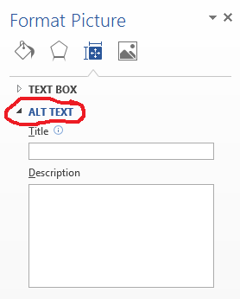
4. Perform steps 2 to 5 above for all items in the Word document requiring a caption and/or alternate text description.
5. If the Word document is long, page numbers should be added as well as Style Headings for titles of different sections within the Word document. Page numbers and Style Headings help a blind person navigate and find important topics within the Word document.
6. If any tables exist in the Word document, the first row needs to be set as a Header Row. To do this:
a. Highlight the first row, right click on it and choose “Table Properties”.
b. Click the Row tab on the “Table Properties” dialog box.
c. Select “Repeat as header row at the top of each page” on the Row tab.
d. Click OK.
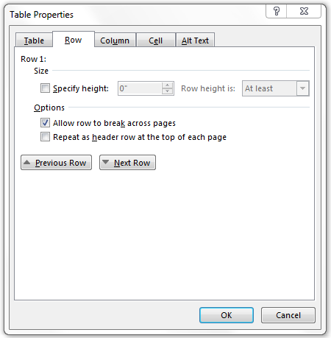

7. Add alternate text to the table:
a. Right click on the table and choose “Table Properties”.
b. Click the Alt Text tab in the “Table Properties” dialog box.
c. Add a Title if you wish, but you should definitely add an alternate text Description.
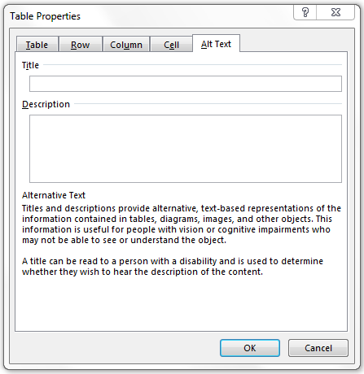
8. Keep the tables as simple as possible. It is best to use black as the cell borders and for the cell border width, select a size one bigger than the default cell border width.
9. Sometimes, depending on the complexity of the table, a caption explaining the table in more detail as well as a table title can be helpful.
10. If any automatically numbered lists exist in the Word document, these numbered lists have to be converted into regular text because Text-To-Speech readers will not read automatically numbered lists in Word documents. To change these automatically numbered lists to regular text:
a. Place the cursor at the beginning of the first item in the list and click the Backspace key on the keyboard to delete the first number in the list.
b. Manually type the same number followed by a period and a space. The item will indent like it is automatically creating a numbered list again.
c. Click the Undo button at the top of Word and it will cause the item to move back to the left margin. Now, the item is numbered as regular text and can be spoken by Text-To-Speech software.
d. Perform steps A through C above for every item in the numbered list to convert them into regular text.
11. If any underscores exist in the document, these should be changed to a “line shape” because depending on the electronic voice used when reading the document with Text-To-Speech software, it may read each and every underscore on the line and that would be monotonous. If you add a “line shape” instead of underscores, Text-To-Speech readers will not read them because they act like a “picture” and require alternate text to be added to the “line shape” in order for Text-To-Speech readers to read them. As long as there is no alternate text added to the “line shape”, Text-To-Speech readers will ignore the line.
12. If the Word document is a test and some questions as well as answers do not have punctuation at the end to act as a reading pause, when using Text-To-Speech readers as well as Screen Readers, all the words will run together and sound like the electronic voice is reading too fast. When in reality, there is no punctuation to act as a reading pause to help those listening to the text comprehend what is being said. Therefore, if there is no punctuation at the end of a question, a colon would be a good option to add. If there is no punctuation at the end of multiple choice answers to a question, a semicolon would be a good option to add.
13. Once all the steps above have been performed, if necessary, then the Word document should be properly accessible.
14. To make sure the Word Document is accessible, you can run the built-in Accessibility Checker by clicking on the File tab and choosing Check for Issues and then Check Accessibility. This will display a list of potential accessibility issues, if any, and will guide you in fixing these problems.
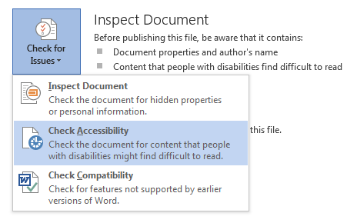
A NOTE ABOUT WORD DOCUMENTS TESTS: Sometimes, especially when working with Word document tests, it is easier to copy the entire original inaccessible document and paste it into a new document as “unformatted text” to get rid of any formatting all at one time. This removes all automatically numbered lists all at once converting them into regular text as Step 10 above states. Then begin performing the steps in the tutorial to make an accessible Word document. When doing this, usually you will get large spaces between the number or letter and the corresponding question or answer. A real easy way to remove excess spaces or even unwanted text (dingbats) is to use the “Replace” function on the Home tab. Typically you want one space between the number or letter and the corresponding question or answer. Thus, to perform this “Replace” function first highlight the space in question with the mouse, then copy the space and click on “Replace” on the Home tab. Paste the copied space into the “Find What” field and in the “Replace With” field type one space. Then click the “Replace All” button to replace every space that is too big all at once. The “Replace” feature saves an enormous amount of time when editing the Word document for accessibility.

Revised: March 2016

